Object Oriented Programming

Homework 8

Xiufeng Cheng

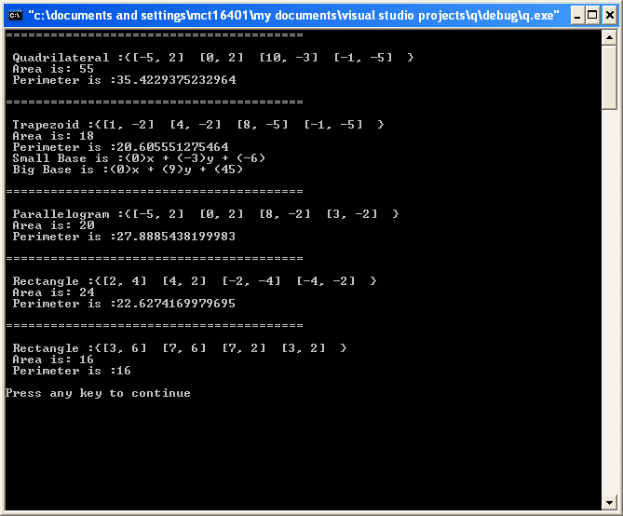

**// Point.h**

// Point class represents an x-y coordinate pair.

#pragma once

#using <mscorlib.dll>

using namespace System;

// Point class definition implicitly inherits from Object

public __gc class Point {

public:

Point(); // default constructor

Point( int, int ); // constructor

Point::~Point()

{

Console::WriteLine( S"Point4 destructor: {0}", this );

}

__property int get_X()

{

return x;

}

__property void set_X( int value )

{

x = value;

}

__property int get_Y()

{

return y;

}

__property void set_Y( int value )

{

y = value;

}

String *ToString();

private:

int x, y; // point coordinates

}; // end class Point

**// Point.cpp**

// Member function definitions for class Point.

#include "Point.h"

// default (no-argument) constructor

Point::Point()

{

// implicit call to Object constructor occurs here

}

// constructor

Point::Point( int xValue, int yValue )

{

// implicit call to Object constructor occurs here

x = xValue;

y = yValue;

}

// return string representation of Point

String *Point::ToString()

{

return String::Concat( S"[", x.ToString(),S", ", y.ToString(), S"] " );

}

**//line.h**

//Line class represents an line consist of two points.

#pragma once

#include "Point.h"

public __gc class Line

{

public:

Line();// default constructor

Line(Point * , Point *);// constructor

__property Point* get_P1(){

return p1;

}

__property Point* get_P2(){

return p2;

}

__property void set_P1(Point * value){

p1 = value;

}

__property void set_P2(Point * value){

p2 = value;

}

double length();

double slope();

double ACoefficient();

double BCoefficient();

double CCoefficient();

String *Line::ToString();

private:

Point * p1;

Point * p2;

};// end class Line

**//Line.cpp**

#include "Line.h"

#define MAX (999999);

Line::Line()

{

}

Line::Line(Point* pointValue1, Point *pointValue2)

{

P1 = pointValue1;

P2 = pointValue2;

}

double Line::slope()

{

if(P2->X - P1->X)

return (P1->Y - P1->Y)/(P2->X - P1->X);

else

return MAX;

}

double Line::length()

{

return Math::Sqrt((P1->X - P2->X) * (P1->X - P2->X) + (P1->Y - P2->Y) * (P1->Y - P2->Y));

}

double Line::ACoefficient()

{

return P2->Y - P1->Y;

}

double Line::BCoefficient()

{

return P1->X - P2->X;

}

double Line::CCoefficient()

{

return (P2->X)*(P1->Y) - (P1->X)*(P2->Y);

}

String *Line::ToString()

{

return String::Concat(S"(",this->ACoefficient().ToString(),S")x + (",

this->BCoefficient().ToString(),S")y + (",

this->CCoefficient().ToString(),S")");

}

**// Quadrilateral.h**

#pragma once

#include "Line.h"

//Trapezoid,Parallelogram,Rectangle,Square will inheret to this class

public __gc class Quadrilateral

{

public:

Quadrilateral();

Quadrilateral(Line *, Line *, Line *, Line *);

~Quadrilateral();

String * ToString();

//Line properties

__property Line * get_L1()

{

return l1;

}

__property void set_L1( Line *value )

{

l1 = value;

}

__property Line * get_L2()

{

return l2;

}

__property void set_L2( Line *value )

{

l2 = value;

}

__property Line * get_L3()

{

return l3;

}

__property void set_L3( Line *value )

{

l3 = value;

}

__property Line * get_L4()

{

return l4;

}

__property void set_L4( Line *value )

{

l4 = value;

}

double distanceFromPointToPoint(Point *p1,Point *p2);

double calculatePerimeter();

double area();

protected:

Line *l1;

Line *l2;

Line *l3;

Line *l4;

}; // end class Quadrilateral

**//Quadrilateral.cpp**

#include "Quadrilateral.h"

Quadrilateral::Quadrilateral()

{

}

Quadrilateral::Quadrilateral(Line *line1, Line *line2, Line *line3, Line *line4)

{

L1 = line1;

L2 = line2;

L3 = line3;

L4 = line4;

}

Quadrilateral::~Quadrilateral()

{

}

/*

Below is very important function, it calculate the area of a quadrilateral no matter what shape it is.

*/

double Quadrilateral::area()

{

double area = 0;

double diagonal_1 = this->distanceFromPointToPoint(L1->P1,L3->P1);

double diagonal_2 = this->distanceFromPointToPoint(L2->P1,L4->P1);

double abcd = L1->length()*L1->length()+L3->length()*L3->length() - L2->length()*L2->length() - L4->length()*L4->length();

return 0.25 * Math::Sqrt(4*diagonal_1 * diagonal_1 * diagonal_2 * diagonal_2 -abcd*abcd);

}

double Quadrilateral::distanceFromPointToPoint(Point *p1,Point *p2)

{ double length = 0;

length = Math::Sqrt((p1->X - p2->X) * (p1->X - p2->X) + (p1->Y - p2->Y) * (p1->Y - p2->Y));

return length;

}

double Quadrilateral::calculatePerimeter()

{

return L1->length()+L2->length()+L3->length()+L4->length();

}

String * Quadrilateral::ToString()

{

return String::Concat(S"{",L1->P1->ToString(),L2->P1->ToString(),L3->P1->ToString(),L4->P1->ToString(),

S"}",S"\n Area is: ",this->area().ToString(),S"\n Perimeter is :", this->calculatePerimeter().ToString(),S"\n");

}

**// Trapezoid.h**

#pragma once

#include "Quadrilateral.h"

// Inherits from Quadrilateral

public __gc class Trapezoid : public Quadrilateral

{

public:

Trapezoid();

Trapezoid(Line *, Line *, Line *, Line *);

~Trapezoid();

String * ToString();

private:

bool isParallel(Line *, Line *);

Line * findSmallBase();

Line * findOtherBase();

}; // end class Trapezoid

**//Trapezoid.cpp**

#include "Trapezoid.h"

Trapezoid::Trapezoid()

{

}

Trapezoid::Trapezoid(Line *line1, Line *line2, Line *line3, Line *line4)

{

L1 = line1;

L2 = line2;

L3 = line3;

L4 = line4;

}

Trapezoid::~Trapezoid()

{

}

bool Trapezoid::isParallel(Line * line1, Line * line2)

{

if (line1->slope() == line2->slope())

return true;

else

return false;

}

Line * Trapezoid::findSmallBase()

{

if ( isParallel(L1, L3) ) // function isParallel is used here

return (L1->length() <= L3->length()) ? L1 : L3;

else

return (L2->length() <= L4->length()) ? L2 : L4;

}

Line * Trapezoid::findOtherBase()

{

if ( isParallel(L1, L3) ) // function isParallel is used here

return (L1->length() >= L3->length()) ? L1 : L3;

else

return (L2->length() >= L4->length()) ? L2 : L4;

}

String * Trapezoid::ToString()

{

return String::Concat(S" Trapezoid :" , __super::ToString(),

S" Small Base is :",this->findSmallBase()->ToString(),

S"\n Big Base is :",this->findOtherBase()->ToString());

}

**// Parallelogram.h**

#pragma once

#include "Trapezoid.h"

// Inherits from Trapezoid

public __gc class Parallelogram : public Trapezoid

{

public:

Parallelogram();

Parallelogram(Line *, Line *, Line *, Line *);

~Parallelogram();

String * ToString();

}; // end class Praallelogram

**//Parallelogram.cpp**

#include "Parallelogram.h"

Parallelogram::Parallelogram()

{

}

Parallelogram::Parallelogram(Line *line1, Line *line2, Line *line3, Line *line4)

{

L1 = line1;

L2 = line2;

L3 = line3;

L4 = line4;

}

Parallelogram::~Parallelogram()

{

}

String * Parallelogram::ToString()

{

return String::Concat(S"\n Parallelogram :" , Quadrilateral::ToString());

}

**// Rectangle.h**

#pragma once

#include "Parallelogram.h"

public __gc class Rectangle : public Parallelogram

{

public:

Rectangle();

~Rectangle();

Rectangle(Line *, Line *, Line *, Line *);

String * ToString();

}; // end class Rectangle

**//Rectangle.cpp**

#include "Rectangle.h"

Rectangle::Rectangle()

{

}

Rectangle::Rectangle(Line *line1, Line *line2, Line *line3, Line *line4)

{

L1 = line1;

L2 = line2;

L3 = line3;

L4 = line4;

}

Rectangle::~Rectangle()

{

}

String * Rectangle::ToString()

{

return String::Concat(S"\n Rectangle :" , Quadrilateral::ToString());

}

**// Square.h**

#pragma once

#include "Rectangle.h"

public __gc class Square : public Rectangle

{

public:

Square();

~Square();

Square(Line *, Line *, Line *, Line *);

String * ToString();

}; // end class Square

**//Square.cpp**

#include "Square.h"

Square::Square()

{

}

Square::Square(Line *line1, Line *line2, Line *line3, Line *line4)

{

L1 = line1;

L2 = line2;

L3 = line3;

L4 = line4;

}

Square::~Square()

{

}

String * Square::ToString()

{

return String::Concat(S"\n Rectangle :" ,Quadrilateral::ToString());

}